Name | Tomasz Cholewa, PhD, DSc, Associated Prof.  CEng (Professional Engineer) | 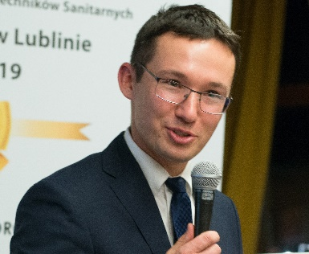
Short CV | Tomasz Cholewa PhD, DSc works at the Lublin University of Technology as Associate Professor.  He cooridates research project about innovative, forecast control of heating system, which is easy applicable in existing buildings.  He was reviewer in many international journals and in EC in topics related to energy efficiency in buildings.  He is professional/licenced engineer (PE) for designing and supervising on building site in frame of heating, ventilation, air conditioning, water supply. He is Chair of Polish Chamber of Sanitary Engineers, Region Lublin. His main research topics are related to energy efficient renovation of existing buildings (especially in field of HVAC), radiant heating/cooling, heat cost allocation in buildings, renewable energy use/integration in buildings.  He is Task Force chair of upcoming REHVA Guidebook “Energy efficient renovation of existing buildings for HVAC professionals”.
Link to publications: | https://scholar.google.com/citations?user=uxjPq_kAAAAJ&hl=pl&oi=ao  https://www.researchgate.net/profile/Tomasz-Cholewa  https://www.linkedin.com/in/tomasz-cholewa-ab051b109/

