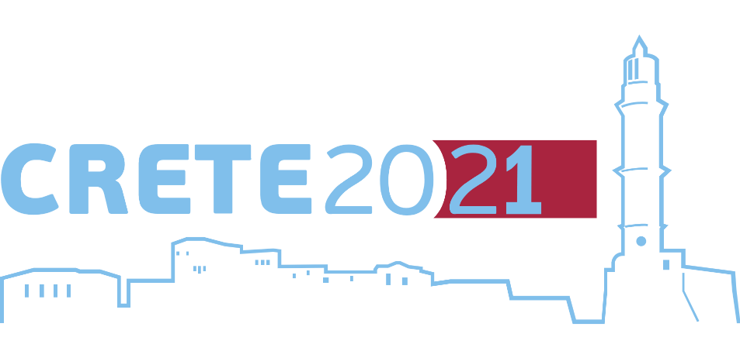
27-30 July
7th International Conference

Industrial and Hazardous Waste Management

Chania – Crete - Greece

hwm-conferences.tuc.gr

Chania 26/3/2021

PRESS RELEASE
The 7th International Conference "CRETE 2021" on Industrial and Hazardous Waste Management will be held in Chania on July 27-30 under the organization of the Technical University of Crete and chaired by Emeritus Professor and President of the IWWG (International Waste Working Group) Evangelos Gidarakos.
The Conference is expected to be attended by internationally renowned scientists, representatives of public and private bodies and companies, active in waste management, in an effort to disseminate scientific research, exchange views and experiences, identify problems and provide specialized solutions.
Given the restrictions imposed by the COVID-19 pandemic and in order to facilitate the participation of any interested, CRETE 2021 provides the opportunity to participate both in person and online. The official language of the Conference will be English, however selected sessions related to the Greek reality will be conducted in Greek.
The Organizing Committee of the Conference is currently pleased to announce the following actions:
- Special Workshop in Greek on "INDUSTRIAL AND HAZARDOUS WASTE MANAGEMENT INFRASTRUCTURE & SERVICES IN GREECE"
- Exhibition and special sessions on "COVID 19 - ENVIRONMENTAL FOOTPRINT".
Civil servants’ participation in CRETE 2021 is provided free of charge upon their registration as members of the IWWG. Also, IWWG members registered for the first time in 2021 are provided with a special discount on their registration fee of 20%.
For more information visit the official website of the conference:
hwm-conferences.tuc.gr
TECHNICAL UNIVERSITY OF CRETE
University Campus, Kounoupidiana, 73133, Chania, Crete, Greece
Tel.: +30-2821006205 | Fax: +30-28210-37850 | e-mail: infoCRETE@isc.tuc.gr

SPECIAL WORKSHOP

INDUSTRIAL AND HAZARDOUS WASTE (IHW) MANAGEMENT
INFRASTRUCTURE & SERVICES IN GREECE

Organizers:
Dr. Panagiotis MERKOS Em. Prof. Evangelos GIDARAKOS
Environmental Inspector IWWG President

The special workshop will be held exclusively in Greek and will focus on the following issues:
- Updated data from the Electronic Waste Register for the actual annual production of IHW, with emphasis on domestic and cross-border transports, storage, reuse, recycling and utilization, as well as final disposal.
- Specifications, capacity, services offered and possibilities of existing, licensed IHW management infrastructure.
- Needs of the country - planning, possible actions and perspectives for the acquisition of managerial competence of IHW, resources saving, circular economy promotion and environmental protection.
- Characteristics and possibilities of existing infrastructure and IHW management services offered internationally - economic and environmental assessment.
- Future needs in IHW management infrastructure and services to cover new waste streams, such as research waste, extraction and distribution of hydrocarbons, waste of photovoltaic systems, wind turbines, energy storage, etc..

EXHIBITION AND SPECIAL SESSIONS

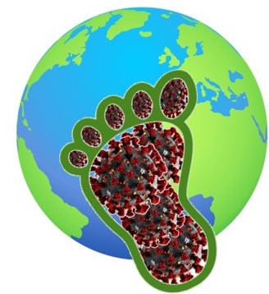
COVID19 | ENVIRONMENTAL FOOTPRINT
In parallel with the CRETE 2021, a special exhibition will be presented, including rich scientific and informative material on the multidimensional impacts of the pandemic worldwide and in particular on the environment and waste management. The exhibition will include visual material in English and Greek, in the form of posters, videos and printed brochures and will be hosted at the heart of the Old Venetian Port of Chania, to facilitate the access of as many visitors as possible.

The Exhibition will be accompanied by special sessions during the Conference by world-renowned scientists, as well as representatives of institutions, which are involved in waste management and are able to convey the recorded impacts.

Contributions (presentations, posters, information material, etc.) on issues related to the subject of the Exhibition are welcome and can be submitted to the Secretariat of the Conference until April 30, 2021.

.
ΠΟΛΥΤΕΧΝΕΙΟ ΚΡΗΤΗΣ μα Μηχανικών Περιβάλλοντος
Πολυτεχνειούπολη, 73133, Χανιά, Κρήτη, Ελλάδα
Τηλ.: +30-2821006205 | Fax: +30-28210-37850 | e-mail: infoCRETE@isc.tuc.gr

