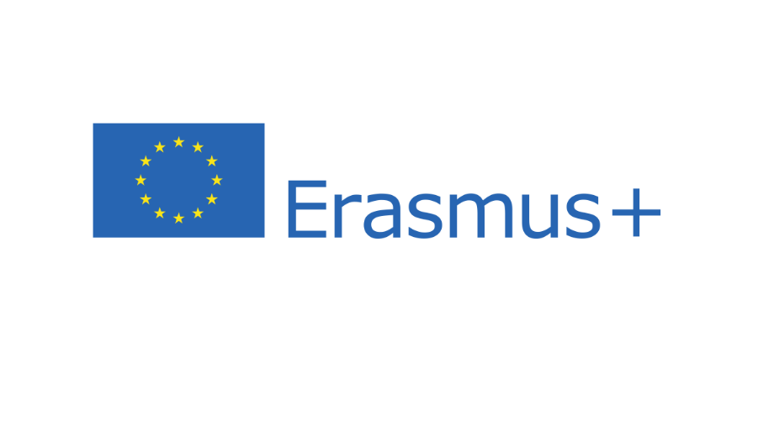

Please fill out this form with the computer
Print it and sign it by hand
Send all application materials in ONE email with subject
‘Application for CirCOOL 2022’ to international@unileoben.ac.at

First name:  Last name: | Academic title:
Birth date: (DD/MM/YYYY)
Passport number:  Nationality: | Passport expiration date:  (DD/MM/YYYY)
Telephone number: | Email-address (check regularly!)
Home address:  Street: | Zip-code:  City:
Emergency contact  First and last name:  Address: | Emergency contact  Telephone number:  Email address:
Home university’s name:
Home university’s address:
Field of study:
Institute/ Department:
Level of study: ☐ BSc ☐ MSc ☐ PhD
Completed ECTS in current study program:
English level: ☐ A1 ☐ A2 ☐ B1 ☐ B2 ☐ C1 ☐ C2

Confirmation of Application and Regulations
I apply for the summer school program CirCOOL 2022 – Responsible Material Flow. This application is binding. MIRO will notify the applicants max. one week after the application deadline (31st of May, 2022), if they were allocated a spot in the CirCOOL program. *Applicants from countries who need a visa for travelling to Austria may receive the confirmation earlier.
I confirm that all data stated herein are correct and allow MIRO to process, save and use the data for internal purposes and share it with my home university.
I confirm to autonomously take on an adequate insurance for the time at Montanuniversität Leoben (travel, health care, accident, liability, repatriation). Montanuniversität Leoben shall not be liable for any losses and/or damages caused intentionally or unintentionally by the participants of the CirCOOL program.
I acknowledge that Montanuniversität Leoben does not cover any travel costs to and from the venue: CirCOOL participants must arrive and depart autonomously and carry their own travel costs to arrive and depart from the venue.

__________________ ________________________________________
Date Signature (print and sign with hand!)

